|  |
| --- |
| Circle Language Spec: Inheritance |

## Class Inheritance

Class inheritance is the traditional form of inheritance: one class takes over all characteristicts of another class. This is displayed as follows:

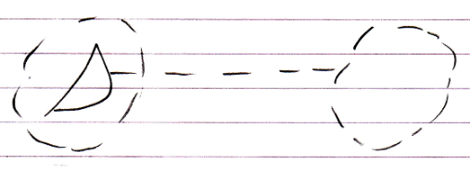

The second class merges with the first class. The first class has an interface that delegates its implementation to the second class.